CALL, EMAIL SEQUENCE FOR A 3-CALL CAMPAIGN
NOTE: Be sure to call at different times of the day if you cannot reach your lead. Morning, evening, or Saturday as examples.
CALL #1 SCRIPT
Hi NAME, I got your name and number as someone in network marketing that might be interested in a plan that is creating much greater levels of success.
Are you currently building a home business now?
YES
That's great! How's it going?
[IF NO GO TO IF YOU COULD CREATE A HOME BUSINESS SECTION]
LISTEN
What would you say is your BIGGEST challenge in growing your business now?
LISTEN
Do you ever wish it was easier?
LISTEN
OPTION 1: IN A BUSINESS NOW: If you could expand your current home business with a portfolio of companies that focus on putting money back into other people's pockets on things they are already buying; and do it through a platform that is creating over 70% success rate, would you want to know more about how that works?
OPTION 2: NO BUSINESS NOW: If you could create a home business with a portfolio of companies that focus on putting money back into other people's pockets on things they are already buying; and do it through a platform that is creating over 70% success rate, would you want to know more about how that works?
When lead responds YES, you have 2-options for moving forward
- GOOD: Send to Residual Income Success Platform landing page at https://www.residualincomesuccessplatform.com/YOURMEMBERID
- BEST: Talk to your team at GPN to find out how they can benefit from the Residual Income Success Plan
I can ask a member of my team to call and see how we could create a win-win together by developing profitable residual income streams. How soon would you like my team to contact you.
LISTEN
Keep in mind; this is a no-pressure, no-obligation free consultation, to see how we could potentially create a win-win situation for you, just like they are for me with the Residual Income Success Plan.
There are over 70% of everyday people like you and me successfully taking action to build their business so it's a no-brainer decision.
Now, I'm happy to set this up for you so you can finally create the income and lifestyle you desire and deserve but I need to ask you one favor.
Can I ask a favor?
YES
These calls are extremely limited – my team and I can only help just a handful of people every week. So if I ask my team to reach out, will you be 100% sure to reply to their text to set a free consultation and answer or return their call at the appointment time so they actually help you?
YES
Perfect. Then expect a text from a member of my team at GPN. They will show you how to set up a time that is convenient for your schedule and help you get started to FINALLY earn the residual income you are looking to create
Sound good?
YES
Expect a text from GPN then. Good luck!

When they choose to talk to your team at GPN
- Go to www.gpncenter.com and log in
- Click Building My Business
- Then click the yellow Add Referrals and Leads button
- Add this prospect as a "Lead."
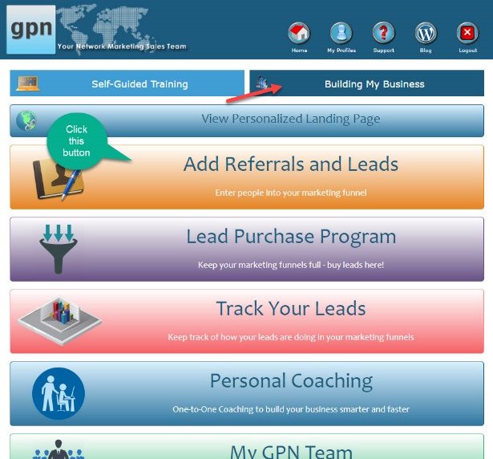.
When you click the lead button, you'll be taken to a form. All you need to do is fill in the blanks
Be sure to fill in the ALL the blanks.
Include notes about your conversation with this lead to help your consultant to be more effective. Please be as detailed as possible
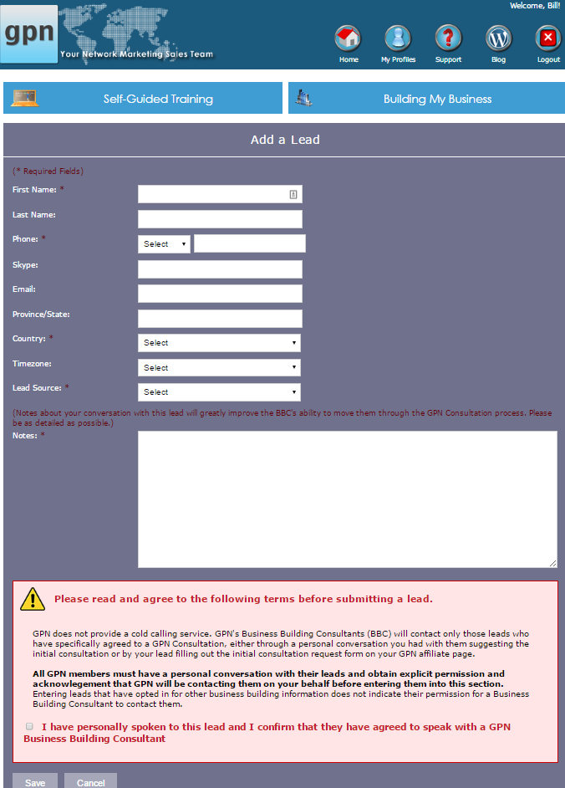
Add Notes per the instructions in white Notes box – Include notes about your conversation with this referral/lead to help your GPN Residual Income Success Consultant to be more effective in their conversation with your potential member. Please be as detailed as possible

Include notes about your conversation with this lead to help your Business Building Consultant to be more effective.
VOICEMAIL
Alternative: Hi NAME, this is YOUR NAME calling from WHERE YOU LIVE., I got your name and number as an individual in network marketing that might be interested in a new way of doing things that is creating much greater levels of success. I wanted to find out if you are you currently building a home business now.
Either way, reach me back at XXX-XXX-XXXX or reply to the email I'll send you in a minute. I'll also send you text if that's easier for you.
I'll talk to you soon
Text to send after leaving a phone message
Hi FIRSTNAME, I just left you a message about your residual income streams. Reach me back at XXX-XXX-XXXX or reply to this text or the email I'll send so we can connect soon. Will you? -YOURNAME
Emails to send
Call #1 Email
SUBJ: The Residual Income Secret
Hi FIRSTNAME,
YOUR NAME here, from YOUR CITY, STATE. I just left you a phone message because I know you're a networker who has been looking for residual income.
If you're like many people, you may have hit a few roadblocks that took you off track.
The unfortunate thing is, without the proper system, building residual income on your own can be hard to impossible for 95% or more of people.
I have a solution to the problem you will want to hear.
I found a way to create a high level of success for our team members by helping them build multiple streams of long term residual income through a portfolio of home businesses that put money back in people's pockets on things they are already buying; i.e., turn your existing expenses into investment strategy.
We are doing it through a platform that has evolved over the past 15 years and is has over 70% of our members successfully taking action to build their business vs. the average in a home business, which is less than 5%.
We are creating a whole new paradigm in home business!
Allow me to introduce the Residual Income Success Plan. We help people like you create a plan that is customized to fit your specific situation.
This provides you with a comfortable path to find prospects for your business and eliminates the need to sell because the initial presentations, follow-up, and enrollment of new members into your team can be done for you.
Find out how you can join us. Get all the facts at https://www.residualincomesuccessplatform.com/YOURMEMBERID.
When you like what you see, request more information from a business building expert by opting in for a free consultation
I'll look forward to seeing how we can create a "win-win" together.
YOUR FIRST NAME
YOUR NAME
XXX-XXX-XXXX
https://www.residualincomesuccessplatform.com/MEMBERID
Call 2 Did You Get This?
SCRIPT
Hi, FNAME, YOUR NAME here in YOUR CITY again – hey I didn't hear back and was concerned you did not get my message. Could you please reply to my email and let me know if you got the message? Thanks. We'll talk soon.
EMAIL
NOTE: Put the first email you sent under this message and send it.
Example:
SUBJ: Did you get this?

Hi NAME,

I'm not sure my messages are reaching you.

Did you get my message below?

Thanks for letting me know.

Let me know what you'd like to do with this information. Are you ready to build multiple residual income streams through a unique vision and platform?

YOUR FIRST NAME

-----Original Message-----
From: YOUR NAME <email@youremail.com>
Sent: DAY, DATE, TIME
To: prospect@yourprospect.com
Subject: The Residual Income Secret
Hi FIRSTNAME,
YOUR NAME here, from YOUR CITY, STATE. I just left you a phone message because I know you're a networker who has been looking for residual income.
If you're like many people, you may have hit a few roadblocks that took you off track.
The unfortunate thing is, without the proper system, building residual income on your own can be hard to impossible for 95% or more of people.
I have a solution to the problem you will want to hear.
I found a way to create a high level of success for our team members by helping them build multiple streams of long term residual income through a portfolio of home businesses that put money back in people's pockets on things they are already buying; i.e., turn your existing expenses into investment strategy.
We are doing it through a platform that has evolved over the past 15 years and is has over 70% of our members successfully taking action to build their business vs. the average in a home business, which is less than 5%.
We are creating a whole new paradigm in home business!
Allow me to introduce the Residual Income Success Plan. We help people like you create a plan that is customized to fit your specific situation.
This provides you with a comfortable path to find prospects for your business and eliminates the need to sell because the initial presentations, follow-up, and enrollment of new members into your team can be done for you.
Find out how you can join us. Get all the facts at https://www.residualincomesuccessplatform.com/YOURMEMBERID.
When you like what you see, request more information from a business building expert by opting in for a free consultation
I'll look forward to seeing how we can create a "win-win" together.
YOUR FIRST NAME
YOUR NAME
XXX-XXX-XXXX
https://www.residualincomesuccessplatform.com/MEMBERID
CALL 3 TAKEAWAY
SCRIPT
YOUR NAME here, from YOUR CITY, STATE. calling again. I realize there is a fine line between good follow up and stalking, and I certainly do not want to cross that line so this will be my final follow-up with you unless I hear back from you.
I'd love to help you get some residual income rolling. I'll email you again with a website to check out and see if building multiple streams of long term residual income through a home business that put money back in people's pockets on things they are already buying would help you now.
This could enable you to start a new business or complement and feed into your current business(es).
Watch for my email.
I don't have another call set so getting help in building residual income is in your hands now. If I don't hear from you I'll assume you are not interested and wish you the best of luck.

EMAIL
SUBJ: The Fine Line…
Hi FNAME, YOUR NAME here, from YOUR CITY, STATE again. I just called and had to leave another phone message.
I realize there is a fine line between good follow up and stalking, and I certainly do not want to cross that line so this will be my final follow-up with you unless I hear back from you.
I'd love to help you get some residual income rolling. I invite you one final time to check out https://www.residualincomesuccessplatform.com/MEMBERID.
See how we're helping people just like you build multiple streams of long-term residual income through a home business that put money back in people's pockets on things they are already buying.
YOU can help BOTH yourself and others turn your existing expenses into an investment strategy.
Remember, we are doing this through a platform that is creating over 70% success rates instead of the meager 5% average home businesses typically experience.
We are creating a whole new paradigm in home business!
If I don't hear from you, I won't be calling again. So getting my help in using this unique residual income plan and platform for residual income building is totally in your hands now.
I hope to hear from you within the next week.
If I don't hear from you, I will assume you are not interested, and I wish you the best of luck.
YOUR FIRST NAME
YOUR NAME
XXX-XXX-XXXX
https://www.residualincomesuccessplatform.com/MEMBERID

